Blaknie Carlile
Hosp 2400 | Auburn University
Restaurant Review
Jim ‘N Nicks

Restaurant Review
Jim ‘N Nicks
Blaknie Carlile

Jim ‘N Nick’s owners, Nick and his father Jim, began slow cooking pork in 1985. They opened their first restaurant in Birmingham, AL, and have opened 34 other locations throughout the southeast since then. Their flavors and hospitality are based off those commonly associated with the south. Growing up in Birmingham, I have been visiting Jim ‘N Nick’s for as long as I can remember. I was relieved to know there was a Jim ‘N Nick’s in Auburn when I moved down for school. My most recent Jim ‘N Nick’s visit was on November 9 of this year.
My boyfriend and I met up with his siblings to have dinner that night. We all ordered different things. My boyfriend ordered a pulled pork sandwich with baked beans and French fries. My boyfriend’s brother ordered the baby back ribs with a baked potato and coleslaw. His sister ordered the chopped southern salad. I ordered the loaded bar b-q baker. This is a classic country bar b-q restaurant. You will be seated and have a waiter or waitress who will be serving you during your dining experience. This restaurant is attractive to many different people. It is most commonly seen as a casual dining restaurant. You will see all age ranges within the dining areas. This bar b-q restaurant is usually seen as having slightly higher prices compared to other similar restaurants. I would say the prices are moderate for the quality that you are receiving.
Their menu provides a large variety of options but they all flow together well to fit in to the bar b-q category. They have 10 different appetizers available. My favorites are the cheese biscuits and homemade bar b-q chips. The next section on their menu is “Garden Picks and Potatoes”. They have 4 salads available and 2 baked potato options. “Soup and Salad” and “Trimmings” are at the bottom of the first page. This is where they talk about their soup and salads of the day and all of their sides. They have all the classic sides that go along with bar b-q dining. My favorite trimming is the macaroni and cheese. The second page of the menu is all about bar b-q. This provides you with tons of options like pork, chicken, or turkey and plate, sandwich, or ribs, etc. Page 3 consist of the other entrees they provide such as steaks, sandwiches, and burgers. The second half of the page is the “Southern Favorites”. This includes different plates, baskets, and sandwiches. The back of the menu provides drink options – non-alcoholic and alcoholic. It also mentions the desserts they offer, their weekly specials, and their catering menu. Everyone agreed that the food was great. My potato was very creamy, warm and melty. Its presentation was very inviting and appetizing to the eye and the stomach.
The ambience consisted of soft country pop playing in the background, modern country décor on the walls and tables. They have a open and welcoming dining area. They have the bar set up in the middle and seating all around it. They also provide a smaller room that can be closed off for a private dining experience or the patio which can be used in the same way. The patio has picnic tables and the booths inside give you a similar feel inside.
The hostess seated us as soon as we entered and informed us of our waitress who would be taking care of us. Our hostess came over a few minutes later to take our drink order and get our appetizer order. She brought our drinks out and took our order for dinner, at this point we had already consumed all of our cheese biscuits except for one. We asked if she would bring out some more. We waited about 10 minutes, still with no biscuits. We asked her again as she walked through the dining room. She promised they would be out soon. We received more biscuits when our entrées came out. This was not ideal, but we got what we asked for. Our waitress did not come back to our table for a while therefore most of our drinks became empty and we had to continue eating with nothing to drink. When she returned she brought us our checks and did not ask if we were interested in dessert. This was not the greatest service I have received at a Jim ‘N Nick’s.
I would compare this restaurant to Country’s Barbecue in Auburn. Review the graphics below for comparisons.
Country’s Barbecue Jim ‘N Nicks
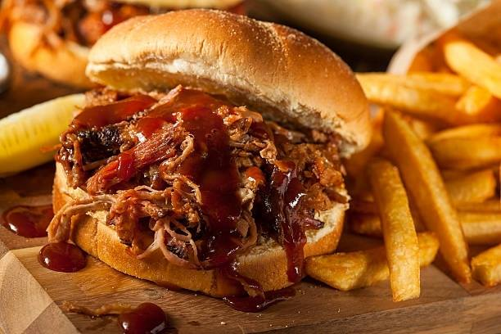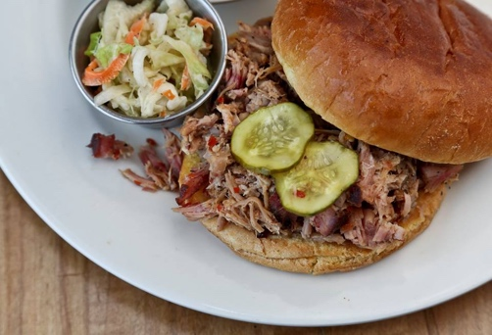

Jim ‘N Nick’s is one of my favorite bar b-q restaurants and I wouldn’t change much, if anything. I would probably just suggest that the staff is all performing at their best ability to keep the guest happy. Making sure that they know what to check for when they are serving a guest. I recommend this restaurant to anyone who is wanting bar b-q and I especially recommend the cheese biscuits.

